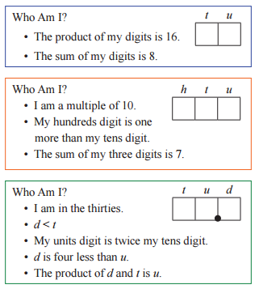Puzzles #1

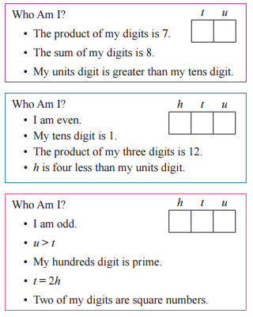

Puzzles #2

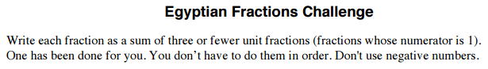

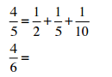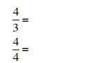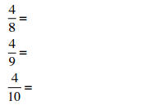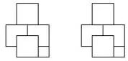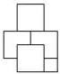

Puzzles #3 1

can or it can

Find the area of the shape using 3 different methods. Ex: be 2 3 be

½ ¼ =3 ¾

=3 ¾

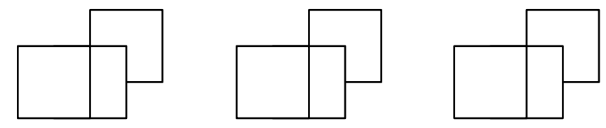

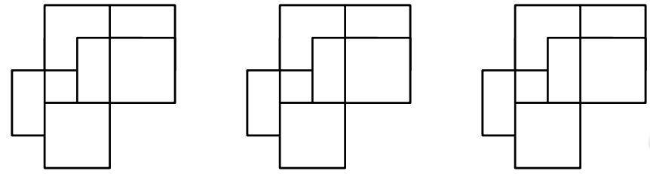

Puzzles #4

Multiply by powers of 10 to make the problems true



x100 =

200

x100 =

600

EX:



Puzzles #5

Multiply by powers of 10 (as decimals) to make the problems true



4

x.01 =

.04









