**MONDAY**

**1.** Compute the following using mental math strategies, then check with a calculator.

**a.** What is 20% of 180? **b**. What is 45% of 90?

**2.** Kids must be 11 years or younger in order to get the Kids Deal at Francesca’s Pizzeria. Write an inequality that represents the ages of students who can get the Kids Deal.

**3.** Solve each proportion.

**a.**  **b.** 

**TUESDAY**

**1.** Hannah’s hourly wage increased from $13.75 to $15.25. What is the percent of change?

[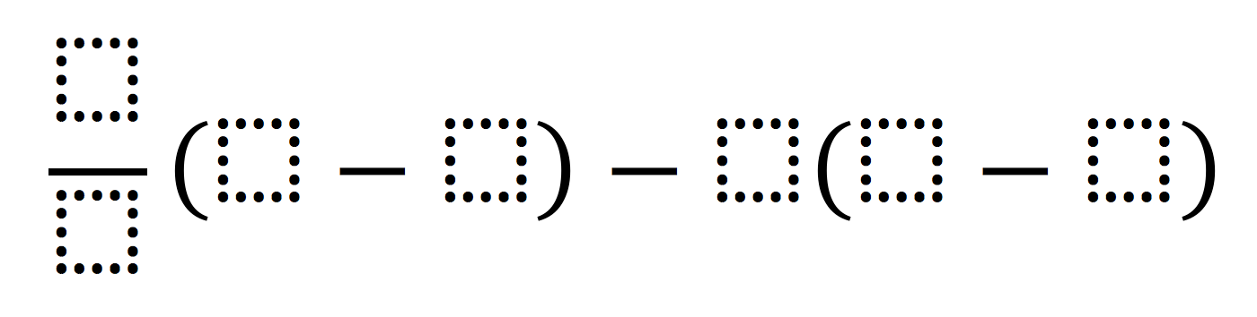](http://www.openmiddle.com/wp-content/uploads/2016/08/Rational-Number-Computation.png)**2**. Using the numbers -5 to 5 at most once each, write an expression that will have the greatest (or least) absolute value.

**3.** Simplify the expressions by combining like terms:

**a**. (2c+ 3h + f + x) + (5c + 3f +2s) – (3f + x) + s **b.** 2(m + 4) + 3m + 6s

**4.** Explain how you can find 50% of 260 using mental math strategies.

**WEDNESDAY**

**1.** You and your family go to a restaurant and order $67.89 worth of food (including tax). Your waiter was awesome and you want to tip her 18%! How much tip is your waiter earning? How much total money is your family spending at dinner?

[](http://www.openmiddle.com/wp-content/uploads/2016/08/orderofops.png)**2.** Use the digits 0 to 9, only once, to make the inequality true.

**3.** Solve each equation.

1. –4x + 7 = 28 **b.** 9(x – 19) = –81

**THURSDAY**

**1.** Alexis was shopping and saw a pair of shoes she wanted for $89.99. She only had $50.00. But! She noticed a sign that said they were 35% off. Does Alexis have enough money for the shoes at the discounted price? If so, how much extra will she have? If not, how much more does she need?

**2.** Explain how you can compute the following WITHOUT using a calculator (mental math strategies!)

10% of 95

50% of 890

25% of 420

**3**. Gas prices decreased from $3.75 a gallon to $3.35 a gallon. What is the percent of change?