**MONDAY**

**1.** Translate each of the following to a percent equation and solve.

**a.** 12 is what percent of 30? **b**. What percent of 200 is 290?

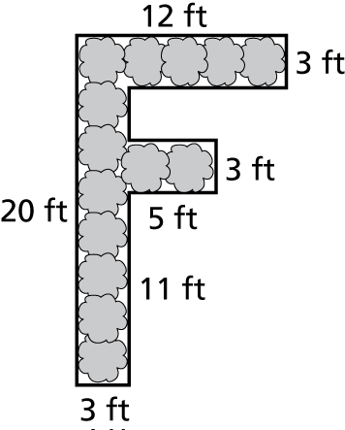**2.** The school garden at Frankfurt Middle School is in the shape of an “F.” A fence is to be built around the garden. The fence costs $2.75 per foot. How much will it cost to install the fence? Explain how you found your answer.

**3.** A box contains ten slips of paper numbered 1 through 10. Find the probability of each event.

**a.**      choosing a number that is a multiple of 2.

**b.**        choosing a number that is less than 10.

**c.**        choosing a 5, replacing it, and then choosing a 6.

**d.**  choosing a 9, NOT replacing it, and then choosing a 10.

**TUESDAY**

**1.** Solve the proportion.

**a.**  **b.** 

**2**. Use the whole numbers 1 through 6, at most one time each, to fill in the boxes and make the largest (or smallest) number that rounds to 5.

**3.** Simplify the expressions by combining like terms:

**a**. (c+ 3h + 4f + x) + (4c + 2f + s) – (f + x) + s **b.** 3(m + 5) + 2m + 2s

**WEDNESDAY**

**1.** Simplify the expressions by combining like terms:

**a.**  **b**. 

**2.** Tell which number is greater.

**a**.  , 95%    **b**. 30%, 0.03 **c.** 150%, 0.15 **d.**  , 11%

**3.** Make a list of your two favorite ice cream flavors and your four favorite ice cream toppings. You are allowed one ice cream flavor and one topping. How many possible combinations might you have?

**Hint**: use an organized list, table, or tree diagram to model the situation.

**4.** Of the 60 students in the seventh grade, 70% own a pet. How many of the seventh grade students own a pet?

**THURSDAY**

**1.** Translate each of the following to a percent equation and solve.

**a.**  is 70% of what number? **b**. What is 140% of 86.8?

**2.** The ratio of men to women at a lecture is 2 to 5. A total of 63 people are at the lecture. How many are men? Explain how you found your answer.

**3.** Explain how you can compute the following numbers WITHOUT using a calculator:

1. 10% of 123
2. 40% of 500
3. 20% of 189